Off The Hoof

Kentucky Beef Cattle Newsletter December, 2023

Cooperative Extension Service
University of Kentucky

Beef IRM Team

Each article is peer-reviewed by UK Beef IRM Team and edited by Dr. Les Anderson, Beef Extension Specialist, Department of Animal & Food Science, University of Kentucky

Contents

This month’s newsletter includes:
Timely Tips – Anderson
Winter Feeding Check-Up and Using the UK Beef Cow Supplement Tool – Laurent
Deciding Who to Cull and When – Arnold

Timely Tips
Dr. Les Anderson, Beef Extension Professor, University of Kentucky
Spring Calving Herd
- Be sure that weaned heifer calves are on a feeding program that will enable them to be at about 65% of their mature weight before the start of the breeding season. Rations should be balanced to achieve gains sufficient to get heifers from their current weight to that “target” weight.
- Body condition is important, plan an adequate winter program for cows to be at least body condition score 5 (carrying enough flesh to cover the ribs) before the calving and breeding season. This will help them to breed early in the spring. Thin cows should be fed to regain body condition prior to winter. Don’t let cows lose weight/condition. Supplementation will most likely be needed. Find low-cost supplemental feeds to meet the nutrient needs of cattle.
- Divide the herd into groups for winter feeding
  - weaned heifer calves
  - first-calf heifers, second-calvers and thin mature cows
  - the remainder of the dry cows which are in good body condition
  - herd sires
- Begin feeding the lowest quality forage to dry cows which are in good condition during early winter and save the best hay for calving time or for weaned calves.
- Order and number ear tags for next year’s calf crop this winter. It is also a good time to catch up on freeze branding and replacing lost ear tags.
Fall Calving Herd
- Get breeding supplies together, if using estrous synchronization and/or A.I.
- Have Breeding Soundness Evaluation (BSE) performed on bulls (even if you used them this spring).
- The fall breeding season starts. Breeding can best be accomplished on stockpiled fescue pasture; otherwise, cows with calves should be fed 25-30 pounds of good quality hay or its equivalent. Supplement with grain, if needed, and minimize hay waste. DON’T ALLOW THESE COWS TO LOSE BODY CONDITION PRIOR TO OR DURING THE BREEDING SEASON. It is easy to wait too long to start winter feeding. Don’t do it unless you have stockpiled fescue.
- Nutrition level of cows during the first 30 days after conception is critical. Pay attention.
- Observe performance of bulls during breeding season. Watch cows for return to estrus, if you see several in heat, try to determine the cause and consider changing bulls.
General
- Complete soil testing pasture to check for fertility and pH.
- Consider putting down geotextile fabric and covering with gravel in feeding areas before you begin hay feeding to minimize waste of expensive hay. Or, perhaps, construct concrete feeding pads for winter feeding areas.
- Monitor body condition and increase feed, if needed, for all classes of cattle.
Winter Feeding Check-Up and Using the UK Beef Cow Forage Supplement Tool
Kevin Laurent, Extension Specialist, University of Kentucky

Winter feeding is in full swing and for operations in the drier regions of the state, hay feeding has been going on for quite some time. So, depending on your particular situation, now might be a good time to reevaluate and fine tune your winter feeding program.

- Inventory your feed resources. By now you should have an idea of how readily cows are consuming the hay you have offered. With roughly 120 days of feeding left to go, take inventory of hay on hand, and determine if supplies will be adequate. It would be better to purchase hay now than in late winter when you are down to your last rolls. In areas of the state that got adequate moisture, and if not already utilized, there may be some winter grazing available. Remember that in most cases, stockpiled fescue holds its nutritive value well throughout the winter and will usually meet the needs of a lactating cow. Spring calving herds may choose to defer grazing on stockpiled pasture until February or March and utilize these acres for a calving pasture or for new pairs. Fall calving herds will want to graze these pastures now since cows are lactating and being bred.

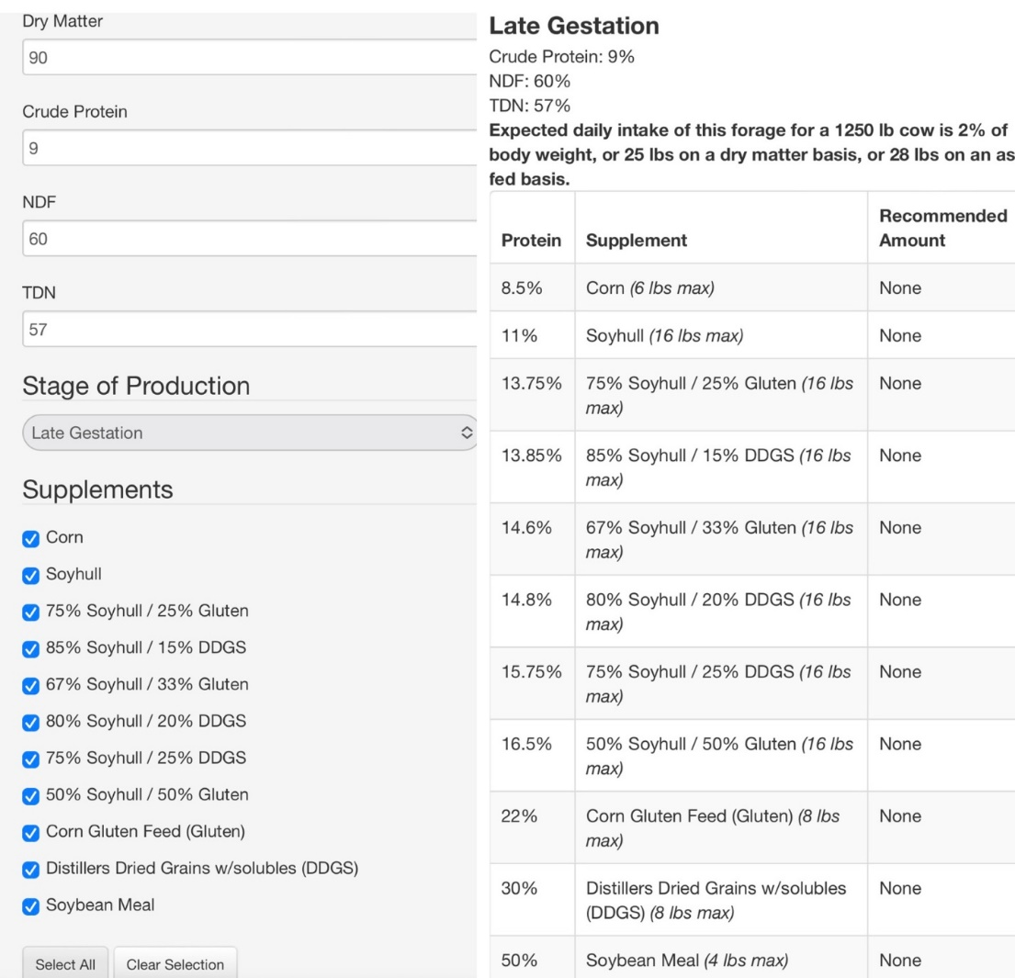
- Test your hay, weigh a few rolls, and use the UK Beef Cow Forage Supplement Tool Beef Forage Supplement Tool (uky.edu). It is not too late to test your hay. With winter feed costs accounting for most of the cow-calf budget, knowing the nutritive value of your hay and how to adequately supplement is imperative. Hay analysis results can be entered in the UK Beef Cow Forage Supplement Tool which is a web-based app that can be loaded on a smart phone. The app uses dry matter, crude protein, neutral detergent fiber (NDF), and total digestible nutrients (TDN) to estimate intake and supplementation needs for cows in three stages of production (mid-gestation, late gestation, lactation). Calculations are based on a 1250 lb. cow in a body condition score of 5. An example of the input and output screens are shown below. Notice that the hay in this example would not need any supplementation for a cow in late gestation but would require supplementation after calving. In the latter case, approximately 3 lbs. of DDGS should adequately meet the lactating cow’s needs if she consumes 28 lbs. of hay. Remember there is a difference between hay consumption and hay disappearance. Knowing what your hay weighs and accounting for feeding waste is essential to estimating intake. Weigh a few rolls over truck scales to get an idea of bale weight. In most cases we tend to overestimate what round bales weigh. Once you have an idea of hay consumption, you can adjust the NDF number on the app to match what the cattle are consuming. A lower NDF value will estimate a higher hay intake and a higher NDF value will estimate a lower intake. Knowing the actual hay intake will enable you adjust supplement rates for a more accurate diet.

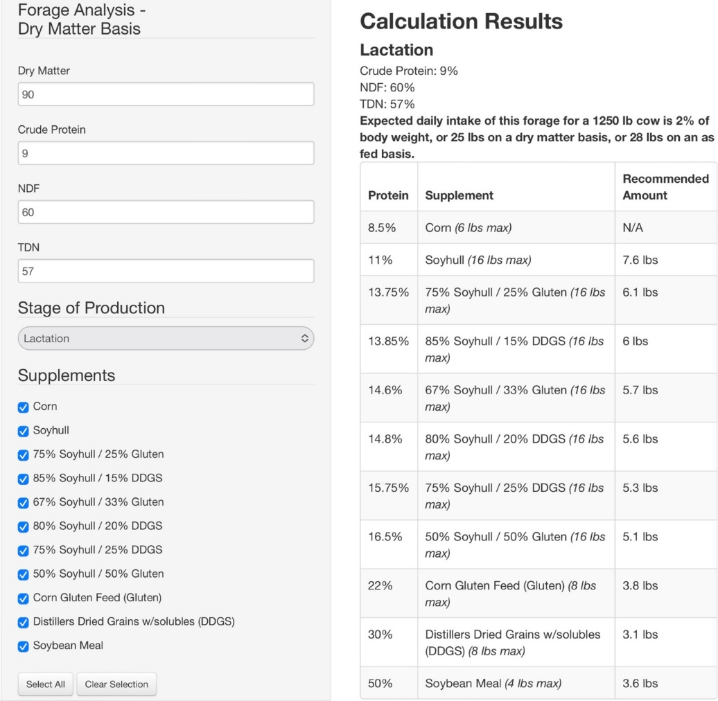
- Monitor body condition. The old saying “the eye of the Master fattens the stock” is a very appropriate proverb for describing the typical winter feeding scenario. Developing an “eye of the Master” is essential to knowing if the feeding program is adequate. Even the best planned feeding program can be affected by adverse weather or other environmental issues. When we see cattle daily, we may become “barn blind” and not be able to see gradual changes in body condition. One idea to monitor condition is to take smart phone pictures every 2-3 weeks of certain cows or groups. This may make it easier to detect changes in condition and adjust feeding accordingly. Remember the goal is a body condition score of 5-6 at calving (no backbone, no middle ribs, no sharp hooks) and maintain this condition from calving to breeding.
We are currently in a unique situation with higher than average cattle prices coupled with higher input costs. The successful producers will be the ones that can adequately feed the cowherd to maintain reproductive performance while also keeping a handle on feed and input costs. Here’s to a winter of little mud and favorable weather.

Deciding Who to Cull and When
Dr. Michelle Arnold, UK Veterinary Diagnostic Laboratory

Which cows in your herd are consistently making you money? Every year, the cow-calf producer needs to critically evaluate each female and decide if she is paying her upkeep or if she needs to be removed or “culled” from the herd. This is exceptionally important during times of drought or a year with marginal hay production as culling deeper in the herd may be necessary to manage the forage supply. There are also times it makes sense to keep or buy more replacement heifers and let older cows go, such as when the herd is getting older, cull cows are selling at favorable prices and the potential replacement heifers have the genetic potential to produce better quality calves. Open cows (those that are not pregnant) at the end of breeding season obviously are high on the cull list as they are difficult to justify financially. Beyond pregnancy status, what other variables are important to evaluate? Structural soundness, body condition score, age, annual performance, and disposition are significant factors to consider when developing a “culling order” specifically for your farm. In addition, it is important not to keep replacements from sires or dams with undesirable traits that are heritable. The culling order is essentially a ranking of the most important reasons a cow would NOT be a productive member of the herd on your farming operation. The following is a list of factors to carefully consider when deciding who to cull this year.
Reasons to Cull:
- Mean Disposition
- Open Females
- Structurally Unsound/Chronic Health Condition
- Advanced Age
- Poor Performance-Records
- Phenotype-color, stature
- Replacement Heifers that get pregnant late in the breeding season
- Disposition. A cow’s attitude is an important consideration in any cattle operation. Bad behavior has both a genetic component and is also learned by her calf at an early age. Mean, nervous, “high strung” cattle are dangerous to people, damage facilities, tear up fences and make gathering and working cattle difficult at best. Remember, a good cow can be protective of her calf without being dangerous and destructive. Bulls that show aggression towards humans should be culled immediately.
- Pregnancy Status. A cow should produce a calf once a year and the sale of that calf needs to pay the dam’s “living expenses”. Diagnosing a cow as “open” (not pregnant) is as simple as having a veterinarian palpate for pregnancy at least 40 days after breeding or after the bull is removed. There are also several simple, inexpensive blood tests available on the market that may be used post-breeding to determine pregnancy status. If multiple cows are found open at pregnancy check, work with your veterinarian to try to determine the cause. Summer heat and fescue toxicosis can be important contributors to low conception rates as well as infectious causes of abortion and early embryonic death.
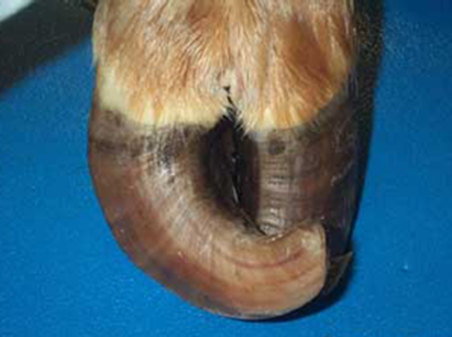
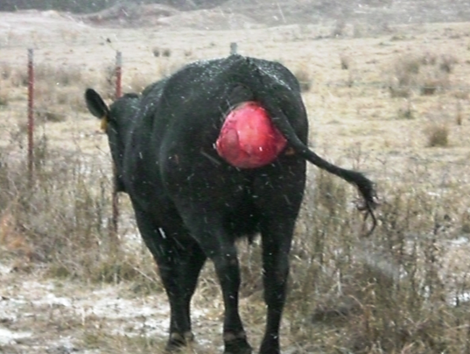
- Structural Soundness. Cattle exhibiting structural problems that adversely affect performance and are not correctable need to be identified and removed. Good feet and legs are essential for maintaining body condition, breeding, calving, self-defense, and raising a calf. A conformational defect such as corkscrew claw (Figure 1) is regarded as a heritable trait and a strong reason to cull. Other structural problems such as cows that have repeated episodes of vaginal prolapse during pregnancy (Figure 2), or cattle extremely sensitive to the effects of fescue toxicosis, should be removed from the herd as soon as the calf is weaned.
Figure 1: Corkscrew claw (also called screw claw) is a heritable defect found most often in the outside claws of the rear legs. There is twisting of the toe in a way that places the side wall of the hoof in direct contact with ground. The condition begins with toes pointing inward instead of forward and leads to lameness due to improper weight distribution. Corrective trimming is necessary every 3-4 months. Photo from: https://nwdistrict.ifas.ufl.edu/phag/2016/05/27/watch-for-a-lameness-issue-in-cattle-called-corkscrew-claw/

Figure 2: Cow with prolapsed vagina. This problem, seen in some pregnant cows, will reoccur year after year and is a strong reason to cull.

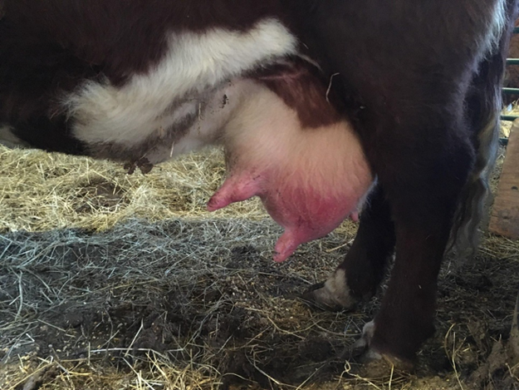
- Udder Quality. Milk production in beef cows is one of the most important factors affecting calf pre-weaning growth and body weight at weaning. A structurally sound udder should be firmly attached and high enough that newborn calves can easily find and latch onto clean, average-sized teats. Cows with blind or light quarters, funnel or balloon shaped teats, teats that drag in the mud or with any previous history of mastitis are strong candidates for culling. Mastitis (Figure 3) will result in decreased milk production, reduced calf weaning weights, and lifelong damage to the quarter. Udder quality in beef cattle is moderately heritable so females with good, or bad, udders tend to pass that trait to their daughters. Culling these cows with poor teat and udder conformation and selecting replacements with better udder traits will make a noticeable difference in calf performance.
Figure 3. Cow with mastitis in the left rear quarter.
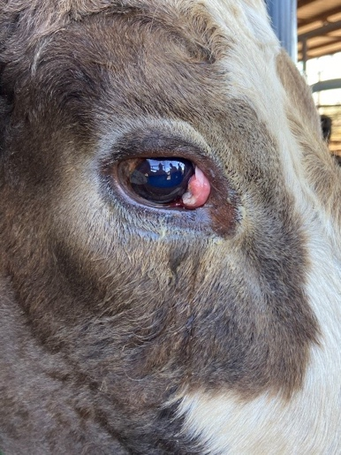
- Chronic Disease. Cows showing signs of chronic disease conditions that will not improve should be culled and only sold for slaughter. Two examples of chronic disease conditions include diarrhea and progressive weight loss from Johne’s Disease and bovine ocular squamous cell carcinoma or “cancer eye” (Figure 4). Waiting too long to cull may result in carcass condemnation at slaughter.
Figure 4: Cow with early cancer eye. Photo from: https://blogs.extension.msstate.edu/theriskproject/ocular-lesions-in-cattle-series-part-ii-cancer-eye/

- Age. Cows are considered most productive between 4-9 years of age. The size and shape of the teeth can be used to assess age but always evaluate tooth wear considering the diet. Cows that eat gritty or sandy feeds and forages have increased tooth wear beyond their years. Regardless, cows with badly worn or missing teeth may have a difficult time maintaining body condition. However, aged cows that stay in good condition and raise a calf every year do not have to be removed just because of advanced age.
- Poor Performance. Record keeping is an invaluable tool for evaluating performance. Readable visual tags on both the cow and calf allow one to match calf sale weights to their respective dams and identify cows that did not produce a calf. Dams with inferior genetics and poor milk production produce lightweight calves that do not grow well. An overweight cow with a small calf that doesn’t gain weight as it should generally means the cow is keeping calories to herself rather than producing milk. Calves that get sick prior to weaning may indicate dams that produced poor-quality colostrum or have poor mothering ability. Any health issues, treatments given, and veterinary visit or expenses should be recorded in a standardized format for every herd member. Record any abortions or stillbirths, any difficulties with labor and delivery, and all calf death losses. It is important that all calves born, whether dead or alive, are recorded and taken into consideration when the herd is being analyzed and record that information on the specific cow’s lifetime history.
- Phenotype. Cows that do not “fit” the herd because of external features such as unusual breed, size, muscling, and color are candidates for culling. These challenges may be overcome to some degree by choice of sire to balance out the unwanted traits. Remember that buyers of commercial calves look for uniformity in color, weight, and frame in a set of calves and will pay a premium price for it.
- The last ones to go. If conditions are such that only the best females can remain in the herd, consider selling those with the fewest productive years left such as bred cows over 9 years old. Also, bred heifers or thin cows that conceived late in the breeding season will likely have a difficult time rebreeding next year and may be good candidates to leave while pregnant.
Since 20% of gross receipts in a typical cow-calf operation come from the sale of cull animals, pay attention to price seasonality and body condition score before sending these animals to market. Prices are historically highest in spring and lowest in late fall when spring born calves are weaned and many culls are sent to market. Adding weight and body condition to culls is an opportunity to increase profitability but can be expensive. Work with a nutritionist to come up with realistic cost projections before feeding cull cattle for a long period of time. When it comes to making decisions on who to cull, remember to consider functionality in your environment. Is she an “easy keeper”? Does she keep flesh and condition and raise a good calf, even when feed and forage is limited? Or does she give too much milk or is her frame size so large that you can’t keep weight on her, even when pasture is plentiful? Is her pelvis so small and tight that calving is a problem for her and will become a problem in her offspring? Functionality leads to longevity and improved efficiency. By retaining more young cows in the herd, you can decrease the number of replacement heifers needed each year and cull cows that are only marginally profitable. Young cows also increase in value as they mature because the body weight of the cow and her calf’s weaning weight will continue to increase until approximately 5 years of age. Longevity will also be improved through crossbreeding because hybrid vigor adds essentially 1.3 years of productivity or one more calf per cow! If considering buying heifers, UK has a decision support tool available at https://agecon.ca.uky.edu/budgets (under the Livestock/Forages heading) to help understand how to evaluate the investment potential for bred heifers in your specific circumstances.
Cull Cow Language
Breakers (75-80% lean)- Highest conditioned cull cows (BCS ≥ 7), excellent dressing percentages
Boners or “boning utility” (80-85% lean)- Moderately conditioned (BCS 5-7), well-nourished commercial beef cows (usually highest price cull)
Leans (85-90%)- Lower BCS (1-4), lower dressing percentages, susceptible to bruising during transport and expect more trim loss. Moving cows from lean to boner status can usually be done efficiently

In summary, a herd of easy-keeping, efficient cows is possible through rigorous culling, careful selection of replacements, and retention of young cows. Match your genetics to your management and environment for maximum efficiency, longevity, and ultimately, maximum enjoyment of cattle production.

